Name:
Period:

Art History
Brochure Project

Directions: You have been asked by a museum to create a brochure explaining Classical, Medieval, and Renaissance Art. Use pp. 316-317 for information for your brochure. Make sure your brochure is neatly designed and contains important, accurate information. Your brochure should be designed as follows:

FRONT BACK
Timeline
Your
Name

Period
Title

Classical
Art

Information

Picture
Medieval
Art

Information

Picture

Renaissance
Art

Information

Picture

Rubric
Score | Format | Content | Presentation
4 | Brochure has all of the elements of the project. | All information is accurate and essential to understanding these three styles of art. | Brochure is neatly and attractively completed.
3 | Brochure has most of the elements of the project. | Most information is accurate and/or essential to understanding these three styles of art. | Brochure is somewhat neatly and attractively completed.
2 | Brochure has some of the elements of the project. | Some information is accurate and/or essential to understanding these three styles of art. | Brochure is somewhat carelessly completed.
1 | Brochure has few of the elements of the project. | Information is inaccurate or is not essential to understanding these three styles of art. | Brochure is carelessly completed.

Scoring Guide
Category | Points Possible | Points Earned
Format | 15
Content | 20
Presentation  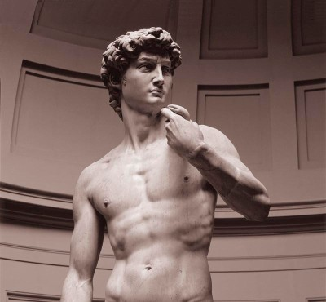 | 15
Total | 50

