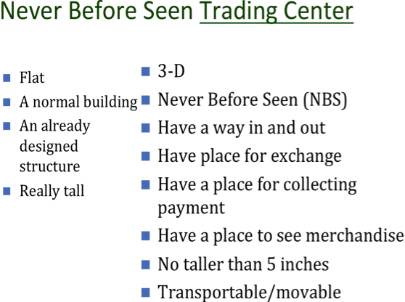

Name: Per.:

Never Before Seen Trading Center Rubric
Has all elements included  -a way in and out  -a place for exchange  -a place for collecting payment  -a place to see merchandise | 1 | 2 | 3 | 4
Creative trading center | 1 | 2 | 3 | 4
Explains trading center clearly | 1 | 2 | 3 | 4
Reflection  -Connects NBS trading center with African trade and concepts | 1 | 2 | 3 | 4
Total: /16 Pts. Grade:
Evaluated with integrity by:

