Names:
Period:

History Movie Project

Project Description: The History Channel has asked you to create an educational movie for their History of the World Series. You and your partner have decided to accept the challenge; perhaps your movie will be nominated for an Academic Award!

Your movie should be between 3-4 minutes in length

How to save your work
- Save your work!
- Go to “My Documents”
- Go to “Lau P#”
- Create a new folder with your name: (i.e. “Alejandro Rodriguez”)

Rubric

5= outstanding 4 = very good 3 = good 2 = needs improvement 1 = HELP!

Category | Points Earned
Argument: Answers essential question effectively
Vocabulary: Uses historical vocabulary and examples to support argument
Summary: Summary answers 5 W’s and H
Credits: Selects and acknowledges evidence from multiple sources
Global connection: Makes connections to multiple world cultures
Implications: Compares and prioritizes choices for ethical action
Format: The movie has a title, concise narration, relevant pictures, smooth transitions, and appropriate music.
Participation: Partners are on task, work quietly and contribute equally to the project
Deadlines: Deadlines are met on time.
Reflection: Provides insightful commentary on what worked and didn’t work about the project.
Total | /50
Defining Civil Rights

Essential Question: ________________________________________________________________________________

Read the definition of civil rights.

Civil rights: the rights that are guaranteed by the Constitution to all people as citizens, especially equal treatment under the law.

What does the word “civil rights” mean in your own words?

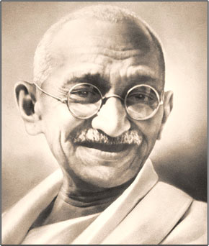
Read these quotes about strategies to achieve civil rights.

“Victory attained by violence is tantamount to a defeat, for it is momentary.” - Mahatma Gandhi

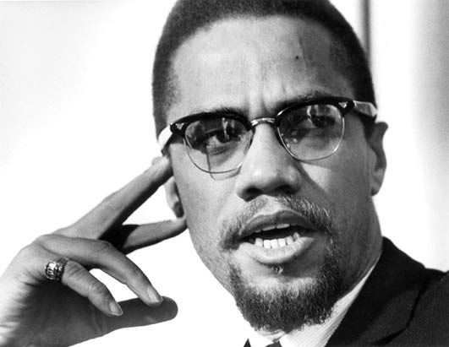
"There is nothing in our book, the Koran, that teaches us to suffer peacefully. Our religion teaches us to be intelligent. Be peaceful, be courteous, obey the law, respect everyone; but if someone puts his hand on you, send him to the cemetery. That’s a good religion."
- Malcom X "Message to the Grass Roots," speech, Nov. 1963, Detroit (published in Malcolm X Speaks, ch. 1, 1965).

How would the following people answer the essential question?

Mahatma Gahndi
Malcom X
You
Research Guide

Essential Question: ________________________________________________________________________________

Research and collect photos and evidence from these sources:

- History Alive! Pursuing American Ideals
- BBC News
- Civics Online

History Vocabulary

Vocabulary | Summary: 5 W’s | Essential Question
Montgomery Bus Boycott
Sit-ins and Freedom Rides
March on Washington
Voting Rights Act of 1965

Civil Rights Act of 1964

Research Guide

Essential Question: ________________________________________________________________________________

Research and collect photos and evidence from these sources:

- TIME Magazine
- The Washington Post
- Oscar Jaramillo’s Weebly Site
- University of Columbia

History Vocabulary

Vocabulary | Summary: 5 W’s | Essential Question
Tahrir Square
Text messaging
Blogging
Web 2.0

Entry Checklist • Documentary

Use the following checklist to prepare your documentary presentation:

Items to Be Completed Date Completed
- Write tentative script that outlines the thesis and questions you will be examining
and the supporting historical information and analysis. _____
- Decide on primary source images, location shots, and interviews, etc ________
- Develop a draft script or storyboard for the presentation, with images noted. ________
- Seek feedback on your draft script from your advisor, teacher, parents, etc. ________
- Take pictures or videotape. ________
- Record script (may include music and sound effects). ________
- Synchronize script with music and visuals. ________
- Include annotated bibliography that cites what sources you used to get your information and pictures ________

Documentary Storyboard

Name(s):______________________________________________________________________
Notes | Visual | Audio
Sample Documentary Script

The following is an excerpt from the first draft of a History Day documentary script (storyboard) about Cesar Chavez. The left column describes images that will be displayed: the right column is the narration text. Primary sources are highlighted and in bold text. (Students were instructed to highlight their primary sources for easy identification.) The total script length was approximately five pages.

-Portrait of Cesar Chavez once said, "Our workers are not filthy beasts to be
Cesar Chavez- feared. They are not lesser than any one of us, nor are they better. They are human, they are American. They are to be treated with
dignity."

-Men and women In California during the 1960's, Cesar Chavez took a stand for
farm workers migrant farm workers rights, and fought against low wages, pesticide
working in fields- poisoning, and poor living conditions. In 1950, male farm workers
were paid $1.10 an hour, while women were paid even less.

-Picture of Helen Chavez recalls, " When the grape harvest was pretty heavy,
Helen Chavez- sometimes I'd work 10 hours a day, 5 days a week, for $.85 an hour."

-Picture of a farm Often times families were forced to bring their children to
worker's family- work so the family could survive.

-Farm workers In addition to low wages, workers suffered inhumane working
working in the conditions. John Gregory Dunne the author of Delano: The Story
fields- of the Grape Strike said, "The workers hunched over the vines
like ducks, there is no air, making the intense heat all but
unbearable. Gnats and bugs swarm out from under the leaves.
Some workers wear face masks; others, handkerchiefs knotted
around their heads to catch the sweat."

-Pictures of fields, and The growers use of pesticides was one of the main contributors
bottle of pesticides- to these inhumane conditions.

-Picture of pesticide The pesticides captan, dinoseb, methyl bromide, parathion and
bottles and DDT caused tumors, childhood cancer, and rashes or open sores
Mr. Yuk stickers- that covered exposed workers’ entire bodies.

-Picture of Lori Salinas- Lori Salinas, a 13 year old farm worker on the McFarland plantation
in California, was one of the many children diagnosed with numerous
tumors, a consequence of exposure to lethal pesticides.

-Workers on Giumarra In 1964, 12 workers in the Giumarra Vineyards in California
plantation- died after working with high levels of pesticides.

-Pregnant woman on the These problems were never given sufficient medical attention.
plantation housing- The workers couldn't afford any health care benefits and the
growers refused to give them any.

