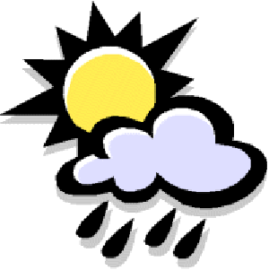
Sample Reflection Checklist
Name:____________________________________

How Was I Like Kevin Henkes in My Writing?

- I started my story with the weather

- I used speech bubbles

- I used repeating words “thought and thought”

- I used internal thinking
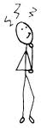
Should I eat chicken or pizza?
Sample Written Reflection
Name: _______________________________________ Unit of Study:______________________________________
1.What did you work on as a writer in this unit of study? Give an example

2. How did it help your writing?

3. What strategies will you bring to the next unit of study?

