A Trip Through Canton:
Picturing Asia with Sam Wineburg as your Guide

Teacher Sam Wineburg. Historical Thinking and Other Unnatural Acts. Philadelphia: Temple
Background: University Press, 2001. Read in particular chapter 5: “Picturing the Past.”

Standards: Standard 10.4 Students analyze patterns of global change in an age of New Imperialism in China
Standard 10.4.1: Describe the rise of industrial economies and their link to imperialism and colonialism (e.g., the role played by national security and strategic advantage; moral issues raised by the search for national hegemony, Social Darwinism, and the missionary impulse; material issues such as land, resources, and technology).
Chronological and Spacial Thinking: Students use a variety of maps and documents to interpret human movement, including major patterns of domestic and international migration, changing environmental preferences and settlement patterns, the frictions that develop between population groups, and the diffusion of ideas, technological innovations, and goods.
- Historical Research, Evidence and Point of View:
    - Students identify bias and prejudice in historical interpretations.
  - Students evaluate major debates among historians concerning alternative interpretations of the past, including an analysis of authors' use of evidence and the distinctions between sound generalizations and misleading oversimplifications.
Students construct and test hypotheses; collect, evaluate, and employ information from multiple primary and secondary sources; and apply it in oral and written presentations.

Goals: Students will use historical thinking skills when labeling a map of Canton based on a variety of sources.
Students will work collaboratively to help recognize that different historians see the same materials differently.

Materials: Initial Canton map with key; text on reverse side
PowerPoing Handout for student note-taking (print 3 slides per page for handout)
PowerPoint presentation for teacher-led discussion
Follow-up map(s) and journal prompts

Anticipatory Set:

Each time we learn about the past, we are taking a trip. What many people don’t think about is packing for that trip. There’s the kind of baggage that you pack on purpose, like GPS or bug spray for a tropical climate. Then there’s the kind of baggage that interferes with experiencing a culture, like expectations about humidity and temperature. Personal example from teacher’s background helpful here. For historians, the tools you need to see the past accurately might include perspective and insight into the viewpoints of actors from the past; the expectations you bring to the task might include your sense of right and wrong, beauty or ugliness.

In this exercise, the class will take a trip back in time to Canton, China around the time of the Opium War. You will not only see the sights of Canton, but you will notice that you packed some helpful things for the trip, and things you thought you wouldn’t need would actually have been quite handy. Like an actual trip, our visit will be four different visits:

- A trip in your imagination, using a map as you plan what to see in Canton.
- A trip you take as you read a travel guide, using the accounts of previous visitors to tell you what’s worthwhile.
- A trip using the best pictures (or, artwork) available at that time, which could have influenced your choices for sightseeing. Personal example helpful here—like postcards.
- A trip to Canton itself, using your own eyes to see the sights.

[When the trip is over, we’ll look at something from the “souvenir shop” and decide whether or not it would be a good memento of our trip to Canton. –long version of PowerPoint only!]

To help you have the best time possible, you’ll be going as a group. The teacher is your guide, but your group will consult with each other to make sense of what the tour guide is telling you.

Teacher Actions | Student Actions
Teacher introduces map and worksheet: “Let’s take trip #1 by activating images already in your imagination. Don’t worry about being historically accurate or politically correct!”  Give out 1 worksheet per student  Read directions aloud.  Circulate to answer questions as students draw.  Direct students to do a “pair/share” with drawings. | Students review features of the map, ask clarifying questions about the locations or areas on the map  Students then fill in the blank boxes with what they imagine any two of the city’s features to look like.  Students trade papers to see how many other students imagined similar parts of the city; compare images
“Now let’s look in the travel guide to see what other visitors have said about Canton.”  Teacher directs student attention to the back of the worksheet, where there are quotes of different visitors to the city. The teacher reads the quotes aloud. | Students ask questions about the quotes.  Students complete back side of worksheet—which feature on the map does the author describe? Would the student want to visit this city feature after hearing this description?
Power Point presentation:  “Now let’s look at some images you might have seen before the Opium War of China, on postcards, for example.”  Teacher shows students 17th and/or 18th century engravings of the city feature that each author was describing.  Look at the presenter notes in the PowerPoint presentation for information about each slide and how to discuss them with students. | Students compare what they thought the feature looked like to what the drawing shows, and what the drawing shows to what the authors described.  Students decide which source had more bias, their own visualization or the authors’ they read.  Students discuss which source is more valuable in “seeing” the feature, their own imagination or the author’s text, or the picture.  Students look at their maps for locations of three places in the short version of the PowerPoint: canal boats, 5 Story Pagoda, and Honan Temple.
“Now let’s look at some photos taken on a trip to Canton.”  Powerpoint Presentation: Teacher shows students photographs from the late 19th century of the city features on the map. | Students repeat the exercise of comparing the authors to the photographs, then the photographs to the drawings. Students discuss prompts in the teacher’s PowerPoint notes.
Extended PowerPoint Presentation: Teacher shows more sets of text/art/photography sites in Canton to reinforce the skills of questioning sources and checking expectations v. reality. | Student comments during presentation show teacher whether mastery of the technique of questioning sources has been mastered or needs more reinforcement.
“Every good vacation includes a bit of shopping for the perfect souvenir!”  Extended PowerPoint Presentation: Teacher shows the souvenir plate from Canton. | Students identify the numbered buildings on the plate, referencing their materials.  Students decide whether this piece of “china” would be a good souvenir to remember their trip to Canton.
Enrichment: Teacher begins next class by reading new script describing how Canton is laid out. (see attached script) | Students look at expanded map of Canton today (Guangzhou) and try to locate pictures on the new map. In other words, students number and create a key for the new map, based on the new text and pictures.
Enrichment: Teacher gives virtual web sites to students for independent study (see attached list of sources) | Worksheets or other assignments from the web site at the teacher’s discretion (extra credit, etc.)

Name: ____________________________________________________________ Period: _______

China: Canton in the 19th Century (Imagining)

Directions: On the map below, the key indicates locations of key buildings in the city of Canton. These places were visited enough by Europeans to be mapped and drawn. Draw in the boxes below your guess about what two of these locations might look like. Do not be concerned about whether these drawings are “artistic” enough but convey generally what you imagine these places look like. Label your drawings and put a line to where the drawing goes on the map below.

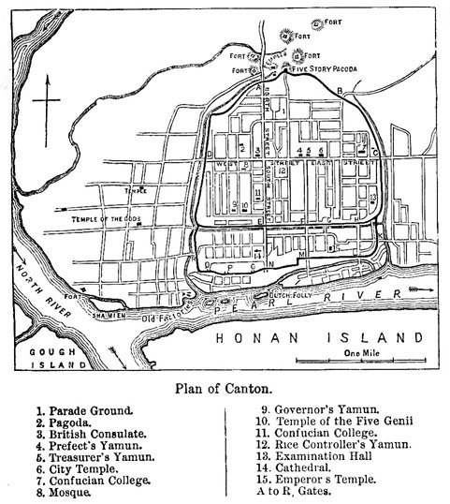

China: Canton in the 19th Century (Text)

Directions: Now that you have imagined Canton using the map and image associations that are unique to you, read the text below. See if these descriptions match your imagination. Try to link each description to one of the places you have drawn by writing down the name of the location on the line next to each text selection.

Estimated Location:  Actual Location: | “On the south banks of the … Pearl River, and on the opposite side from the city of Canton… is the most famous of all Buddhist temples in China, the very cathedral of that contemptible idolatry. Standing on the margin of the water, it is most frequently approached by boats, and the multitude that is in perpetual motion at the landing-place, is calculated to give a very low estimate of the Chinese character. … A small comfortable-looking assemblage of doors, and screens, and gables, and projecting eaves, and concave roofs, and grotesque animals, gives to the landing-place the character of a country ale-house.”
Estimated Location:  Actual Location: | “Canton had a ‘floating’ population of at least 100,000 souls. On its waterways could be found sampans, ‘great’ boats, slipper boats, cargo boats, coffin boats, passage boats, ferry boats, theatrical boats, flower boats, house boats, leper boats, police boats, customs boats, fishing boats, gunboats, steamboats, floating restaurants and brothels, and steam launches.”
Estimated Location:  Actual Location: | Built from 1863 to 1888, this towering Gothic church, the largest in China, has been reopened and is now known as the Shishi Holy Heart Cathedral. To the Cantonese, this towering structure had originally only served to emphasize “political intrigue and French avarice rather than peace and goodwill.”
Estimated Location:  Actual Location: | At 2 metres high, it offered marvelous views of both the city and mountainous countryside. Built in 1380 by Zhu Liangzu during the Ming Dynasty (1368-1644) to flaunt his power and obsession that “he was able to shake the seas and the mountains.” During its more than 600 year long history the tower has been destroyed and rebuilt five times.” [Gallery No. 9]

Enrichment Activity: Canton/Guangzhou Map #2
Read quotes to class; class tries to create new key for the Guangzhou based on reading.
(Boldface text for emphasis not in the original)

Option #1: Preferred Text (Describes Canton itself, late 1700s)

Canton is a big city—it takes almost an hour to read the center by carrying-chair if your house is on the outskirts. The Europeans living there [in the 1780s] guess the city’s population to be around one million, and those who know both cities think Canton is about the same size as Paris, though the buildings are all single-storied, which makes it hard to judge. Canton is really four different cities in one, all of which abut each other. On the north bank of the Pearl River, set back a little from the water, is a walled area known as the “Chinese city,” where the governor-general of the region has his Canton office, as does the Emperor’s supervisor of foreign trade, the “Hoppo,” as the Europeans transliterate his official name. The streets here are narrow and crowded, filled with small shops. North of the Chinese city is a second walled area known, since the Manchu conquest of China in the 1640s, as the Manchu or the “Tartar” city. Most of the Manchu garrison forces live here, and the governor of Guangdong Province has his main office here. With its broad public avenues, many of them paved, interspersed by symmetrically placed and aligned triumphal arches, the Manchu city has a spacious and ordered look, fit setting for the formal buildings where the local officials hold state examinations and perform the solemn ceremonies for Confucius.
West of these two enclaves, the high walls and gate towers of which announce their official status to all visitors, lies a third metropolis, the commercial and residential heart of Canton, with streets paved with slabs of finely laid fieldstone, gracious shops and homes, and the warehouses of the more prosperous merchants stretching along the river bank. In this area, proof of both affluence and a mature sense of comfort, the streets are sheltered with awnings to give protection from the fierce summer sun. The fourth city is one that sprawls along the Pearl River’s edge and in the maze of smaller inland waterways and canals. This is the realm of the very poor and the boat people; here boats are moored in serried rows, their crowded masts jumbled against the sky, making “avenues whose trees are ships,” in the words of a French observer.” (7-8)
“The foreign residents are dispersed in different parts of Canton. In the western suburb, near their spacious European-style church, live the Portuguese Jesuits. … On the river’s edge, just south of the point where the western suburb meets the Chinese city, are the lodgings and warehouses of the foreign merchants, which they call their “factories.” …
The long-distance ocean vessels of all these countries—except for the Portuguese, who use their own colony of Macao nearby—anchor ten miles down the river, at Whampoa Island. It is here that their boats are registered, measured for tax purposes, and inspected by the Hoppo’s subordinates, and that the bulk goods they purchase for shipment to Europe are loaded.” (9)

Jonathan D. Spence. The Question of Hu. New York: Vintage Books, 1989.

Enrichment Activity: Canton Map #2
Read quotes to class; class tries to create new key for the Guangzhou Map based on reading.

Option #2: Description of trading practices in Canton
Students will not be able to place all pictures

“It usually took several weeks to a couple of months to unload the ships. The cargo was often sold and contracted for prior to
unloading it, and then shipped directly to the Chinese merchants'
houses on the quay. This saved them from having to handle the goods
twice. ... After the contract was made, the goods would be unloaded, sent to the foreign factory for weighing and inspection, and then immediately transhipped to the merchant houses. The only import goods stored in the foreign factories were products that did not sell. Sometimes items would be placed in a warehouse for several years if there was a poor market, but foreigners generally tried to sell them in China because they would be subject to export duties if loaded back aboard the ships."
(30)
“The Hoppos tried to minimise the opportunities for smuggling and other illicit activities by restricting foreigners at Wampoa to the island immediately surrounding the anchorage. In Canton, they were restricted to the factories, which were outside the city walls. Monitoring, reporting and controlling of foreigners were introduced to minimise the potential for discord and disharmony. Disagreements or quarrels between foreigners and Chinese were usually dealt with quickly, firmly and, sometimes, harshly as a deterrent to
others." (31)

Paul Arthur Van Dyke. The Canton Trade: Life and Enterprise on the China Coast, 1700-1845. Hong Kong: University of Hong Kong Press, 2005.

Name: _________________________________________ Period: _______

Mapping Canton in the 19th Century (Post-Lesson Exercise)

Directions: The map below shows the city of Canton today (named Guangzhou). On the map below, you will create a key for the locations pictured on the back of the map. Title the pictures on the back in the key below. Then write the number of that picture’s location ON THE MAP ITSELF. To help you, the teacher will read from an 18th century text which describes the Canton area. Note that some of the pictures on the reverse of this worksheet are sites which you previously identified and located on the first map. Do not be afraid to change your mind about the location of the item in the picture; today’s new information may give you an entirely new understanding of how Canton and the Pearl River looked.

- 5.

- 6.

- 7.

- 8.

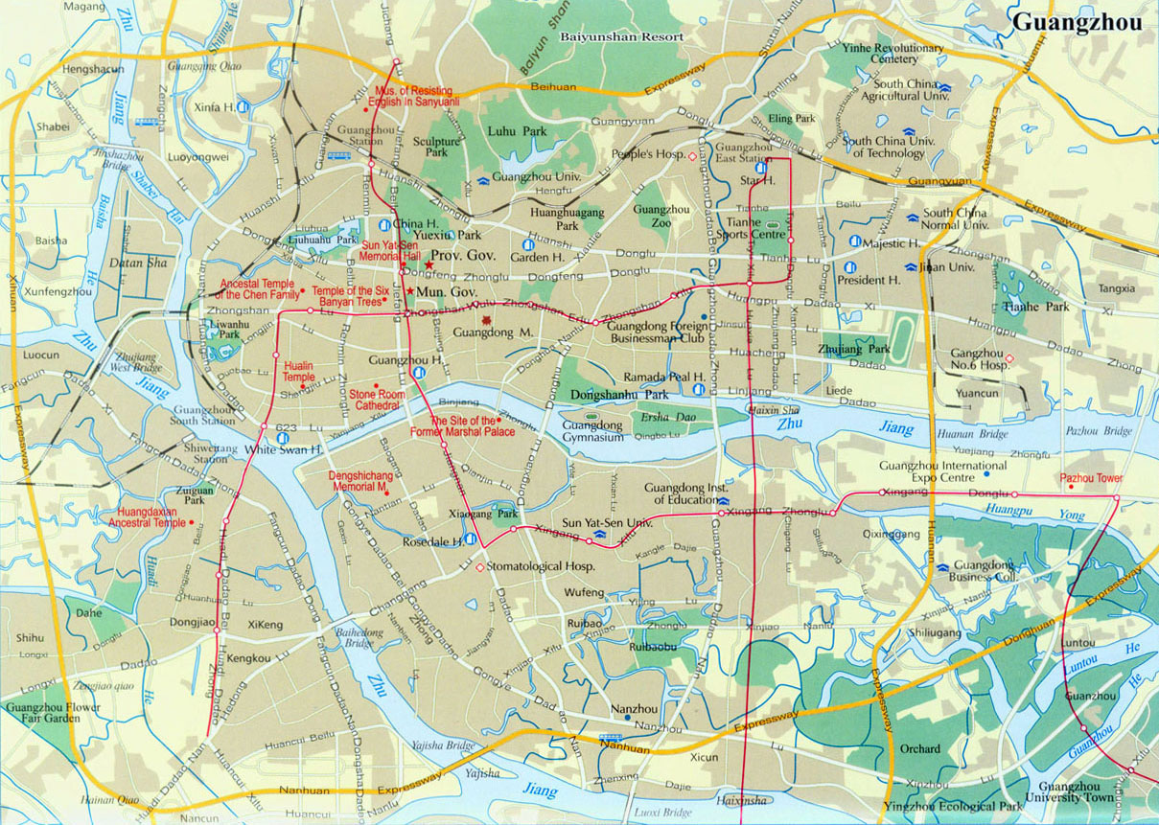
Pearl River Delta photographs
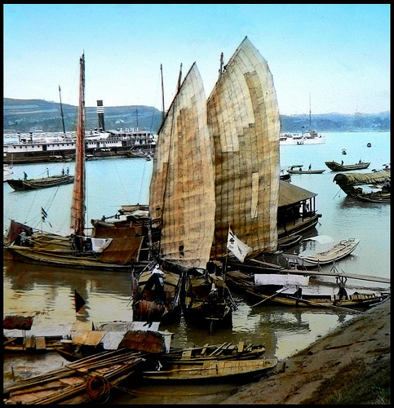 2. 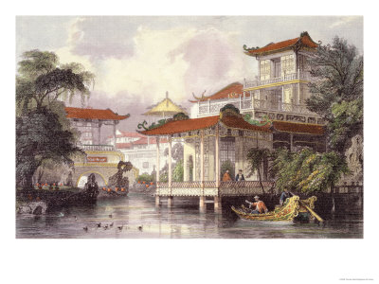
1.
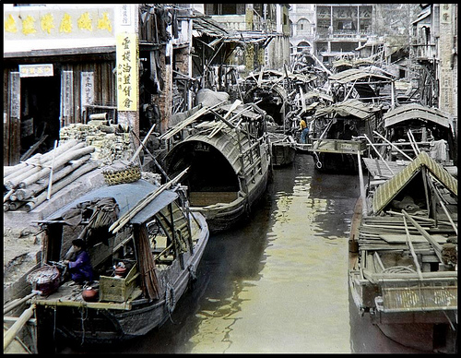 4. 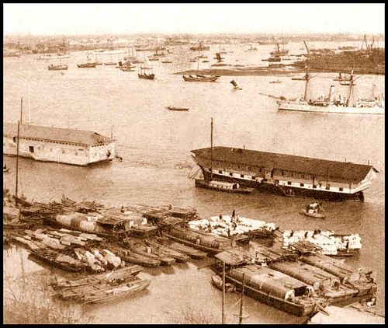
3.
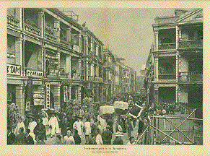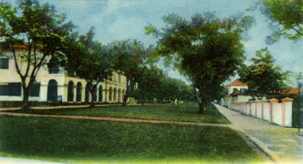
5. 6.

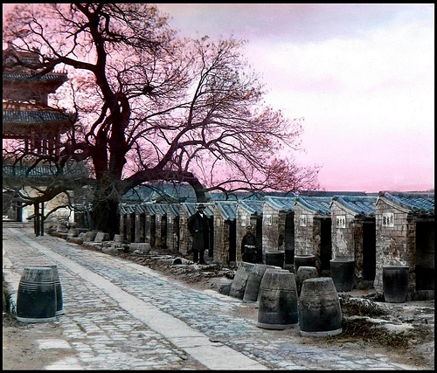 7. 8. 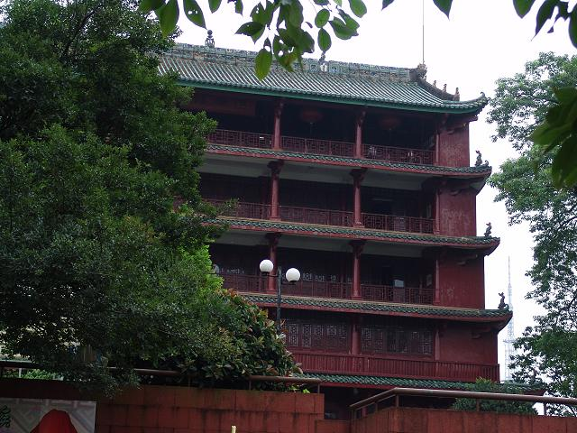

Online Resources: Seeing History

Mark A. Baker. Chinese History: Thomas Allom’s ‘China Illustrated.’ The Chinese Outpost. 1998-2010. Mark A. Baker, publisher. http://www.chinese-outpost.com/history/thomas%2Dallom%2Dchina%2Dillustrated
Read carefully the caveats given on the home page regarding the pictures (Thomas Allom may not have traveled to China at all!) and the commentary by missionary G. H. Wright (extraordinarily xenophobic). The problems posed by the authors of the pictures and text are part of the exercise in looking at their works. PowerPoint, text in worksheet.
More colorized Allom engravings/paintings can be found at this art dealer’s web site: http://www.antiqueprints.com/stock-images/stock/prints/china-prints.html

Antique Prints of China. Philographikon Gallerie. 2010. Ranier Rauhut. http://www.philographikon.com/printschina.html
This private seller of engravings posted works on his web site. The quality does not enlarge well, and the files are .gif files, so beware.

Boerschmann’s Pictures of China (1906-1909): Kuangtung Province. Paul Dudley, ed. PBase.com. 1999-2007. PBase.com LLC. http://www.pbase.com/lambsfeathers/kuangtung
Paul Dudley, a self-professed “old man with a camera” from Australia, posted these pictures from Picturesque China—Architecture and Landscape: A Journey through Twelve Provinces, a book originally published in the early 1920’s by Ernst Boerschmann. Dudley himself took pictures of the Three Gorges Dam in operation, and bridges, etc. under construction in the area which are pretty cool. He also has links to two other 19th century China photos on the home page for the Boerschmann gallery. PowerPoint.

Life Magazine has posted its picture archives, which are searchable through Google (search images; type “Canton China” and the source “Life” to narrow it down). I could not find a single link to make this easier for you to locate the pictures! There is very little description or provenance for the photos searchable through Google. In short, you have to already know what you are looking at to use the photos.

Photo Gallery No. 9: “A Tour of Old Canton.” Presbyterian Archives Research Centre. 2010. Presbyterian Church Archives Research Centre, New Zealand. http://www.archives.presbyterian.org.nz/photogallery9/page1.htm
These photographs were taken by missionaries in China and were turned into stereoviews to show folks back home the strange places they were working. Each picture comes with a location and commentary. Close ups of neighborhoods on a Canton map help locate the places. PowerPoint, text in worksheet.

Old China 中国80-110年前. Okinawa Soba, ed. Flickr.com 2009. http://www.flickr.com/photos/24443965@N08/sets/72157616817817339/
I honestly cannot tell you that “Okinawa Soba” is the name of a real person, but it seems like his claim that he scanned glass lantern slides and stereoviews from the 1895-1930’s period of Chinese history is on the up and up. Bonus: the editor has posted THOUSANDS of photos from a similar time period from Japanese history. Click on his user name to find his home page on Flickr, then browse his collections. Let the browser beware, however—his commentary appears every so often in the captions, so this isn’t necessarily a site to be checked out by kids without some previewing on your own. (His home page features a pile of decapitated heads, for example, as well as choice commentary about people who don’t like his captions.) PowerPoint, text in worksheet.

Paul Arthur Van Dyke. The Canton Trade: Life and Enterprise on the China Coast, 1700-1845. Hong Kong: University of Hong Kong Press, 2005. Text in Enrichment Activity.

Home Accessories: Paintings. The Federalist Online: 18th Century America Recreated. 21 June 2010. http://www.thefederalistonline.com/store/index.php?main_page=index&cPath=1_6
The Federalist is an art dealer in Connecticut who sells through the web site. Reproductions of artwork include scenes from Canton from many time periods, mostly from harbor, transfer easily to presentations. PowerPoint, Enrichment Activity.

Chinese Architecture, Guangzhou: Temple of the Six Banyan Trees. Essential Architecture. 2010. Essential-Architecture.com. http://www.chinese-architecture.info/CA/CA-009.htm
This web site features the china “map” of Canton, with today and past photographs of the same site. The web poster is an architect who is contributing to an on-line community survey of notable architecture. The neat thing about the site is that it corresponds nicely to the artwork in the power point and the map locations. PowerPoint.

Map of the Pearl River Delta. JohoMaps! 2010. JohoMaps!.com. http://www.johomaps.com/as/china/guangdong/pearldelta.html
This map gives a good graphic representation of Canton’s location in relationship to its neighbors. Kids will realize that Canton is not quite so easy to figure out once they see this map. This map is included in your resource packet.

Antiquarian Map Archive. The Probert Encyclopaedia. 2005. http://www.probertencyclopaedia.com/photolib/maps/
This is a British web site, and the map archive seems to have come from a variety of sources (including textbooks). There is an astounding array of random stuff here, but the Victorian- and Edwardian-era maps will be helpful for creating your own “Imagining…” exercise, should you want to create one.

GOOD FOR VIRTUAL FIELD TRIPS:

Asia For Educators: An Initiative of the Weatherhead East Asian Institute at Columbia University. 2009. Asia for Educators, Columbia University. http://afe.easia.columbia.edu/
This web site includes professional development on-line as well as learning modules for students, and lots of resources. Be sure you are not directing students to the professional development part of the site; the reading level sucks the life out of it all if you are not already familiar with the topic! Different age level material is available, K-16.

Massachussetts Institute of Technology. Visualizing Cultures: Image-Driven Scholarship. MIT and the Council on East Asian Studies at Yale University. 2002-2009. http://ocw.mit.edu/ans7870/21f/21f.027/home/index.html
This web site has scholarly essays, pictures with good captions, modules, and resources presented at conferences on many parts of Asia (China and Japan are mostly represented in the modules on display). Preview to make sure the material is comprehensible.

Name: _________________________________________ Period: _______

Imagining Canton in the 19th Century (Pre-Trip Map)

Directions: On the map below, the key indicates locations of key buildings in the city of Canton. These places were visited enough by Europeans to be mapped and drawn. Draw in the boxes below your guess about what these locations might look like. Do not be concerned about whether these drawings are “artistic” enough but convey generally what you imagine these places look like.
North Canton/City Gate
Fort

Examination Hall
Five Story Pagoda
Temple

Canal Boats
Factories

