Dialogue Journals: Quick Start Guide for Teachers
TIIP Team Meeting April 30, 2011 / Better Document-Based Thinking and Learning Poster Presentation

Assignments should scaffold teacher expectations for increased historical analysis and higher levels of Bloom’s taxonomy over time. The following reading assignments can be done with any textbook (and with primary sources as well) and the teacher can intersperse these assignments with other types of homework over an entire year. A copy of two different versions of Bloom’s taxonomy is on the reverse.

This strategy is not effective without teacher feedback to students (at least intermittently, if not consistently). However, it is an excellent way to catch students cheating on homework, if that were your only instructional goal: students cannot persuasively argue that their thoughts are exactly the same! It also allows history teachers to give thoughtful and detailed feedback to ELD and Special Ed coordinators about student reading comprehension.

Student Directions | Teacher Notes
Scan Chapter ____, Section ____’s main headings and subheadings, looking for the most interesting part to read. Read that section and complete a dialogue journal as you read. When you have filled up a single side of one piece of paper, you are done reading. | Model dialogue journals in class before assigning this. The goal with this assignment is to have students practice the technique so you can give feedback. Match your own modeled dialogue journal to levels of Bloom’s taxonomy so students become familiar with it (posting it in class is also helpful).  Repeat this assignment as needed, including the modeling. Require clear, meaningful reflections, even if students are more affective than cognitive.
Scan Chapter ____, Section ____ until you find information about _______________. Read that part of the text. As you read, complete a dialogue journal. | This is additional practice in simply using the dialogue journal format. Here, you are seeing if students can use the features of the textbook to locate information more quickly.  Give feedback to students who have trouble decoding. Guide students who provide mainly affective reflections towards cognitive thought.
Read Chapter _____, Section _____. As you read, complete a dialogue journal. | Now that students have the hang of dialogue journals, and understand the level of reflection you are interested in, you can increase the amount of reading material.  Eventually students should be able to eliminate information from their dialogue journals that merely restates content knowledge, and focus on writing to higher levels of Bloom’s taxonomy.
Read Chapter ____, Section _____ about __________________. As you read, complete a dialogue journal in which you comment on the similarities and differences between what the teacher talked about in class and what the textbook says. | The assignment is now requiring students to use higher levels of thinking by comparing a lecture or lesson in class to the textbook.  When students note the differences between two sources and begin to comment on which is more likely to be correct (with reasons for their thinking), they are ready for more complicated analytical tasks (such as competing viewpoints for document-based essay questions).  You will need to repeat this type of assignment several times to have a critical mass of students demonstrating historical thinking in their dialogue journals.
Read Chapter ____, Section _____ about __________________. As you read, complete a dialogue journal comparing the text to _____.  Then write a paragraph in which you explain which source is more persuasive and why. | Students now move to analyzing techniques that writers (or teachers) use. The dialogue journal is like a warm-up exercise at this point; it also allows the teacher to check for understanding of the writer’s main points and for historical thinking as the student analyzes that source.  The paragraph can be a pre-writing exercise for a DBQ essay or simply practice for introductory paragraphs in DBQ essays.

Richard C. Overbaugh and Lynn Schultz’s Converted Bloom’s Taxonomy

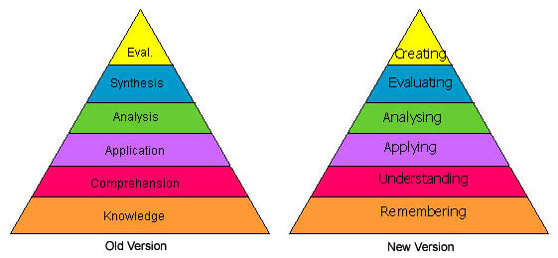

Conversion of Bloom’s original taxonomy into newer language that emphasizes student action (verbs) over processes (nouns)

Remembering: can the student recall or remember the information? | define, duplicate, list, memorize, recall, repeat, reproduce state
Understanding: can the student explain ideas or concepts? | classify, describe, discuss, explain, identify, locate, recognize, report, select, translate, paraphrase
Applying: can the student use the information in a new way? | choose, demonstrate, dramatize, employ, illustrate, interpret, operate, schedule, sketch, solve, use, write.
Analyzing: can the student distinguish between the different parts? | appraise, compare, contrast, criticize, differentiate, discriminate, distinguish, examine, experiment, question, test.
Evaluating: can the student justify a stand or decision? | appraise, argue, defend, judge, select, support, value, evaluate
Creating: can the student create new product or point of view? | assemble, construct, create, design, develop, formulate, write

