The Fight in the Fields
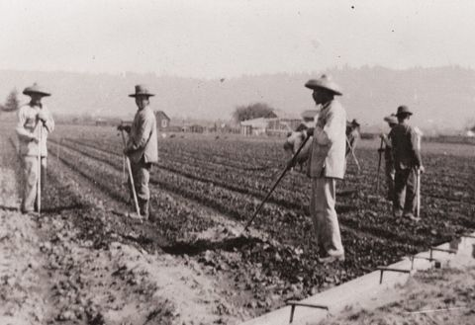 Farm workers in a field

For a long time, there was only one job in Oxnard, California: Picking vegetables in the fields. Almost everyone in Oxnard was a farm worker. They all worked for one big company.

The workers were mostly Mexican and Japanese. They made almost no money, and they couldn't shop in regular stores. They had to buy all their food and clothing in company stores. Everything there was extremely expensive. This was another way for the company to get rich from the poor workers.

The workers wanted to change things. But Japanese workers only helped other Japanese workers, and Mexican workers only helped other Mexican workers. When Mexican workers asked for more money, the company fired some of them and hired more Japanese workers. The same thing happened to Japanese workers.

This changed in 1903. That year, Mexican and Japanese workers started a new union. This was the first time in American history that farm workers from two different races started a union. All the workers demanded more money, and to get rid of the company stores. The company said “no” to their demands.

The union had a strike. No one would work until they got their demands. There was a fight, and the company guards killed one of the Mexican workers. The newspapers wrote many stories about it. The workers won the strike! The workers got more money and didn’t have to shop in company stores.

The workers wanted to join a bigger union. The biggest and most powerful union in the US was called the AFL. But almost everyone in the AFL was white. They said that the Mexican workers could join – if they got rid of the Japanese workers. There were no Asian workers in the AFL.

The Oxnard farm workers said no. They knew that workers were strong when they were together, but weak when they were apart. It was a long time before the AFL learned this.

Vocabulary
- extremely – adverb – Very much. “I was extremely unhappy to lose my job last week.”
- demand – verb and noun – To say you must have something (verb) or what you want (noun).
Verb: “We demand safer work.” Noun: “Health insurance is one of our demands.”
- get rid of – To make something go away. “Let’s get rid of these old, dirty clothes.”
- strike – noun – When workers stop working until they get their demands. “The strike was two weeks long.”
- race – noun – What part of the world someone comes from, and what they look like. In America, the races are Latino, Asian-American, African-American, American Indian and white. “Do you think people of different races can work together?”
Vocabulary Practice

1.__ extremely | a. What part of the world someone comes from, and what they look like.
2.__ demand | b. To make a new union
3.__ get rid of | c. Very much.
4.__ strike | d. To say you must have something, or what you want.
5.__ race | e. When workers stop working to get their demands.
6.__ __________ | f. To make something go away.

Questions

1. Who worked in the fields in 1903? Who works in the fields today?

2. What problems did the Oxnard farm workers have before the strike? What problems do farm workers have today?

3. What happened in Oxnard when only the Mexican workers or only the Japanese workers asked for more money?

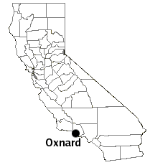

4. What did the Oxnard farm workers do?

- Why did the AFL ask the union to get rid of Japanese workers? Why did the union say no?

Attributes | Exemplary | Proficient | Basic | Limited
Historical  Content | Includes all of the following:  - Specific actions the landowners and labor contracting company took  - How the union was formed and its importance  - Specific demands made by the union and why  - Specific steps the striker would like the community to take to support the strike and why  - How this action connects to one or more of the 5 basic principles of our Constitution | Includes most of the following:  - Specific actions the landowners and labor contracting company took  - Specific demands made by the union and why  3 . Specific steps the Striker would like the Community to take to support the strike and why  4. How this action connects to one of the 5 basic principles of our Constitution. | Includes some of the following:  - Specific actions the landowners and labor contracting company took  - Specific demands made by the union and why  3 . Specific steps the Striker would like the  community to take to support the strike and why | Includes one of the following:  - Specific actions the landowners and labor contracting company took  - Specific demands made by the union and why  3 . Specific steps the  Striker would like the  Community to take  To support the strike  And why
Historical  Perspective | RAFT maintains clear, consistent point of view, tone, and ideas relevant to role played; | RAFT maintains clear point of view with ideas relevant to role played | RAFT maintains clear point of view with some ideas relevant to role played | RAFT does not consistently maintain clear point of view and has few ideas relevant to role played
Focus | RAFT stays on topic, never drifting from required form or type; historical details and information are accurate and included to develop purpose | RAFT stays on topic, never drifting from required form or type; use of some historical  details and information  to develop purpose | RAFT stays on topic, sometimes drifting from required form or type; very little use of  historical details to develop purpose | RAFT off topic, drifting from required form or type; historical details and information are inaccurate or irrelevant
Essential Question  Response | RAFT clearly and convincingly organizes historical information to connect one or more of the Constitutional principles to the strike | RAFT clearly organizes historical information to connect one of the Constitutional principles to the strike | RAFT attempts in a basic way to organize historical information to connect one of the Constitutional principles to the strike | RAFT makes little or no attempt to organize historical information to connect one of the Constitutional principles to the strike

