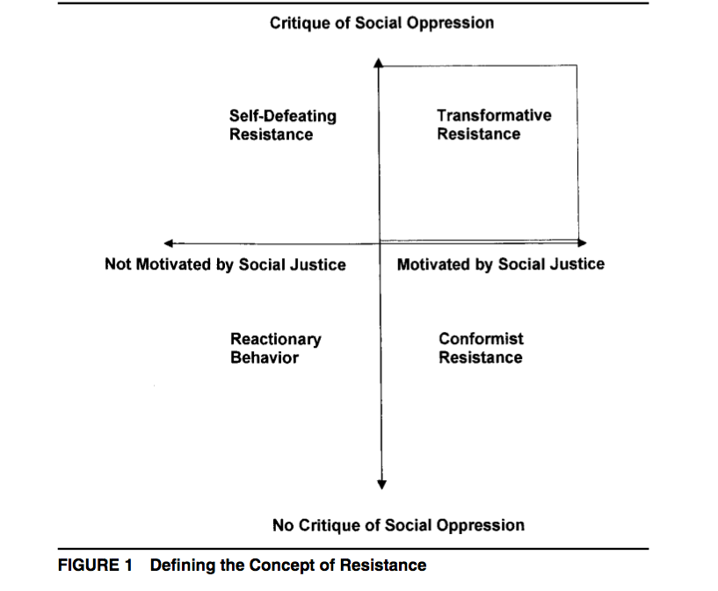
EXAMINING TRANSFORMATIONAL RESISTANCE THROUGH A CRITICAL RACE AND LATCRIT THEORY FRAMEWORK
Chicana and Chicano Students in an Urban Context
DANIEL G. SOLORZANO
University of California, Los Angeles
DOLORES DELGADO BERNAL
University of Utah

Reactionary behavior. The first type of oppositional behavior is not a form of resistance because the student lacks both a critique of her or his oppressive conditions and is not motivated by social justice. An example of reactionary behavior is the student who acts out or behaves poorly in class, the schoolyard, or the community and has no critique of the social conditions that may contribute to her or his disruptive behavior. In addition, the student is not motivated by an interest in social justice and may challenge the teacher or other authority figures “just for kicks” or “to see the teacher sweat.”
Example:

Self-defeating resistance. This is the traditional notion of school resistance. Self-defeating resistance refers to students who may have some critique of their oppressive social conditions but are not motivated by an interest in social justice. These students engage in behavior that is not transformational and in fact helps to re-create the oppressive conditions from which it originated. An example of self-defeating resistance is the high school dropout who may have a compelling critique of the schooling system but then engages in behavior (dropping out of school) that is self-defeating and does not help transform her or his oppressive status (at least not in the long run) (see Fine, 1991). Although the construct of self-defeating resistance acknowledges human agency, one might argue that it does so in a limited way by only considering a partial understanding of the systems of oppression and demonstrating behaviors that can be destructive to oneself or others.
Example:

Conformist resistance. The third type of resistance refers to the oppositional behavior of students who are motivated by a need for social justice yet hold no critique of the systems of oppression. These students are motivated by a desire to struggle for social justice yet engage in activities and behavior within a more liberal tradition. They want life chances to get better for themselves and others but are likely to blame themselves, their families, or their culture for the negative personal and social conditions. They offer “Band-Aids” to take care of symptoms of the problem rather than deal with the structural causes of the problem. In other words, these students choose to strive toward social justice within the existing social systems and social conventions. However, based on this classification scheme, this behavior is resistant because the student exhibits one of Giroux’s (1983a, 1983b) criteria—being motivated by the goal of social justice. An example is the student who thinks the best way to change the high drop-out rate at her or his school would be to offer tutoring and counseling so that the dropouts can adapt to the ways of the school. The student would probably not challenge institutional practices, question the relevancy of the pedagogy and curriculum, or examine the effect of socioeconomic factors. Although some social change is possible through conformist resistance, without a critique of the social, cultural, or economic forms of oppression, it does not offer the greatest possibility for social justice.
Example:

Transformational resistance. The fourth form of resistance refers to student behavior that illustrates both a critique of oppression and a desire for social justice. In other words, the student holds some level of awareness and critique of her or his oppressive conditions and structures of domination and must be at least somewhat motivated by a sense of social justice. With a deeper level of understanding and a social justice orientation, transformational resistance offers the greatest possibility for social change. This type of resistance differs from the self-defeating resistance of Michelle Fine’s (1991) dropouts because it does not serve to strengthen the oppression and domination of the person. The manifestations of transformational resistance can take on many forms but will look very different than the “street-corner” behavior that often implicates students even further in their own oppression (McLaren, 1993).

In her work on critical media literacy, Tara Yosso (2000) built on this model of resistance and examined some of the many manifestations of Chicana and Chicano students’ transformational resistance, including their attempt to “prove others wrong.” Proving them wrong seems to be a process in which students “(a) confront the negative portrayals and ideas about Chicanas/os, (b) are motivated by these negative images and ideas, and (c) are driven to navigate through the educational system for themselves and other Chicanas/os” (p. 109). She elaborated on the arsenal of subtle strategies that students engage in during the process of resistance and extended transformational resistance to include resilient resistance. She defined resilient resistance as “surviving and/or succeeding through the educational pipeline as a strategic response to visual microaggressions” (p. 180). Resilient resistance is at the
intersection between conformist and transformational resistance where the strategies students use “leave the structures of domination intact, yet help the students survive and/or succeed” (p. 181).
Example:

