Community Cultural Wealth in Our America

After discussing Tara Yosso’s Community Cultural Wealth theory, find examples of the 6 types of capitals in the novel Our America. Describe the situation and the form of capital being utilized.

Type of Capital | Quote | Page # | Explanation of why this quote is an example of capital
Aspirational
Linguistic
Familial
Social
Navigational
Resistance

Exploring Cultural Capital

When you think of society, do you think that racism and inequity play a big role? Do you think that you do not have opportunities and capital/assets/resources like others? Well, you do! Let’s learn about the capital you DO have in your community.

Using Tara Yosso’s theory of Community Cultural Wealth, let’s take a look at the different forms of capitals we have in our communities.
------------------------------------------------------------------------------------------------------------
Adapted from Tara Yosso’s University of California, USA:
Whose culture has capital? A critical race theory discussion of community and cultural wealth
Race Ethnicity and Education
Vol. 8, No. 1, March 2005, pp 69-91

The capital you will be discussing is Aspirational Capital.

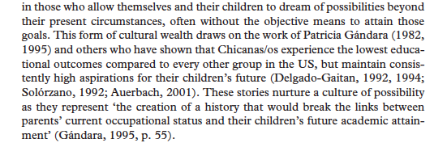
Describe the concept of Aspirational Capital in your own words and then apply it to your life:

Exploring Cultural Capital

When you think of society, do you think that racism and inequity play a big role? Do you think that you do not have opportunities and capital/assets/resources like others? Well, you do! Let’s learn about the capital you DO have in your community.

Using Tara Yosso’s theory of Community Cultural Wealth, let’s take a look at the different forms of capitals we have in our communities.
------------------------------------------------------------------------------------------------------------
Adapted from Tara Yosso’s University of California, USA:
Whose culture has capital? A critical race theory discussion of community and cultural wealth
Race Ethnicity and Education
Vol. 8, No. 1, March 2005, pp 69-91

The capital you will be discussing is Linguistic Capital.

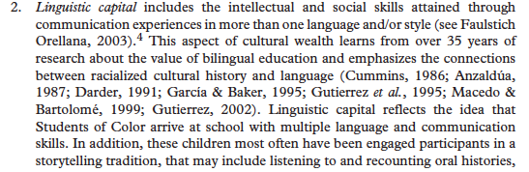
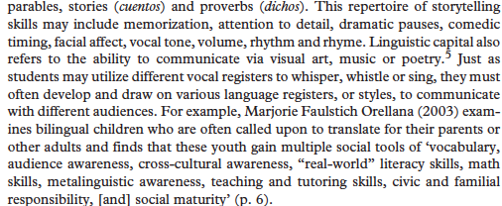

Describe the concept of Linguistic Capital in your own words and then apply it to your life:

Exploring Cultural Capital

When you think of society, do you think that racism and inequity play a big role? Do you think that you do not have opportunities and capital/assets/resources like others? Well, you do! Let’s learn about the capital you DO have in your community.

Using Tara Yosso’s theory of Community Cultural Wealth, let’s take a look at the different forms of capitals we have in our communities.
------------------------------------------------------------------------------------------------------------
Adapted from Tara Yosso’s University of California, USA:
Whose culture has capital? A critical race theory discussion of community and cultural wealth
Race Ethnicity and Education
Vol. 8, No. 1, March 2005, pp 69-91

The capital you will be discussing is Familial Capital.

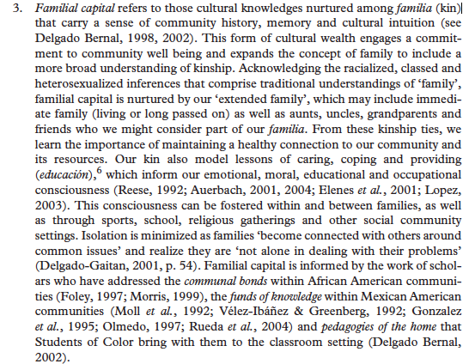

Describe the concept of Familial Capital in your own words and then apply it to your life:

Exploring Cultural Capital

When you think of society, do you think that racism and inequity play a big role? Do you think that you do not have opportunities and capital/assets/resources like others? Well, you do! Let’s learn about the capital you DO have in your community.

Using Tara Yosso’s theory of Community Cultural Wealth, let’s take a look at the different forms of capitals we have in our communities.
------------------------------------------------------------------------------------------------------------
Adapted from Tara Yosso’s University of California, USA:
Whose culture has capital? A critical race theory discussion of community and cultural wealth
Race Ethnicity and Education
Vol. 8, No. 1, March 2005, pp 69-91

The capital you will be discussing is Social Capital.

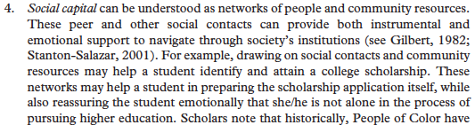
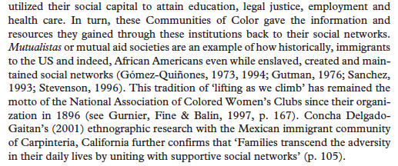

Describe the concept of Social Capital in your own words and then apply it to your life:

Exploring Cultural Capital

When you think of society, do you think that racism and inequity play a big role? Do you think that you do not have opportunities and capital/assets/resources like others? Well, you do! Let’s learn about the capital you DO have in your community.

Using Tara Yosso’s theory of Community Cultural Wealth, let’s take a look at the different forms of capitals we have in our communities.
------------------------------------------------------------------------------------------------------------
Adapted from Tara Yosso’s University of California, USA:
Whose culture has capital? A critical race theory discussion of community and cultural wealth
Race Ethnicity and Education
Vol. 8, No. 1, March 2005, pp 69-91

The capital you will be discussing is Navigational Capital.
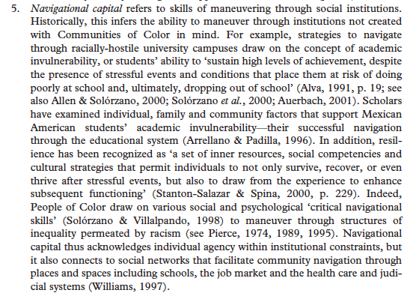

Describe the concept of Navigational Capital in your own words and then apply it to your life:

Exploring Cultural Capital

When you think of society, do you think that racism and inequity play a big role? Do you think that you do not have opportunities and capital/assets/resources like others? Well, you do! Let’s learn about the capital you DO have in your community.

Using Tara Yosso’s theory of Community Cultural Wealth, let’s take a look at the different forms of capitals we have in our communities.
------------------------------------------------------------------------------------------------------------
Adapted from Tara Yosso’s University of California, USA:
Whose culture has capital? A critical race theory discussion of community and cultural wealth
Race Ethnicity and Education
Vol. 8, No. 1, March 2005, pp 69-91

The capital you will be discussing is Resistant Capital.
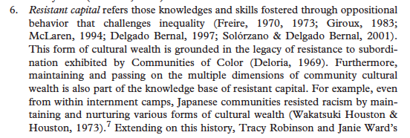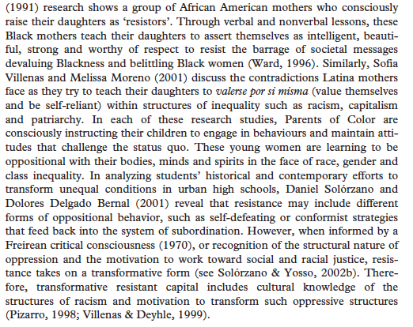

Describe the concept of Resistant Capital in your own words and then apply it to your life:

