In Spite of a Fence
By Craig Buck

Excerpt from article in Westways magazine

. . .
In the 1860’s, Crocker had supervised the building of the transcontinental railroad from the West eastward. He would rightfully brag of being the man who built the railroad. When construction began in January 1863, Crocker, a Sacramento drygoods merchant, knew nothing about railroad building. He summed up his experience by saying, “I know how to manage men.”
Crocker attacked the project with the obstinate zeal that was to become his hallmark, riding up and down the rails so often in his private coach that if he awoke in the night, he could pinpoint his location by the sway and shake of the train. During the first six years of construction, Crocker boasted of not having spent more than three consecutive nights in his Sacramento bed.
The sight of his 250-pound mass strutting through the construction areas, with his stern eyes and bird’s-nest beard, kept the laborers on their toes. “I used to go up and down the line …like a mad bull,” he later recalled, “stopping along wherever there was anything going amiss, and raising Old Nick with the boys that were not up to time.” He became increasingly overbearing and gruff, characteristics about which even his wife complained.
As the project grew, Crocker found it difficult to recruit enough laborers. The Irish workers that made up the bulk of his labor force either refused to leave their families to work for the railroad, or would sign on until the tracks neared mining country, then take off to discover their fortunes. The railroad petitioned the War Department for 5,000 Rebel prisoners as free labor, but the scheme ended when the war did.
Crocker finally decided to hire Chinese workers, over the protests of his partners, his trusted foreman, and workingmen’s organizations afraid of being undercut by cheap foreign labor. Within six months he had hired 2,000 coolies, and had sent to China for more. They were industrious, easy to provide for and prohibited, by law, from working in the mines. Without them, the railroad would not have been built.
At first Crocker and his Chinese (“Cholley Clocker’s pets”) were ridiculed. Crocker would retort, “They built the Great Wall of China, didn’t they?” But the coolies soon proved themselves as the railroad scaled the Sierra Nevada. In the winter of 1865-66 they lived and worked in tunnels dug under forty-foot snowdrifts. At Cape Horn, a sheer 1,000-foot drop, the Chinese were lowered on ropes, dangling in midair, to chisel a ledge in the hard rock, wide enough to lay tracks.
At the top of the Sierra route was a forty-mile segment, much of which ran through a series of tunnels. But the granite was so hard that blasting powder would shoot out from the pitted walls, like cannon shot, without damaging he rock. Picks and chisels merely blunted against the granite. Crocker ordered a shaft built into the center of the uppermost summit tunnel so that workers could not only work in from both sides of the projected passage, but also from the center outward. Despite 500 kegs of black powder daily, the tunnel progressed only by eight inches a day. Three locomotives, iron for forth miles of track, and tons of food and supplies were hauled up on sleds.
. . .
In 1867 Crocker began construction of thirty-seven miles of snow-sheds across the tracks at the summit. Two hundred carpenters and a dozen sawmills were kept occupied for two years building the shed system so the railroad could run throughout the winter. When Crocker first began building the sheds, he was again ridiculed; when completed, they were hailed as the greatest engineering feat of the century.
In 1877, however, the major construction was behind him. . . . What the railroad didn’t bring in legitimately, he gleaned from government land grants and building subsidies.
The most notorious example of this occurred thirteen years earlier when the tracks were approaching the western base of the Sierra. Congress had fixed a subsidy of $16,000 per level mile of track, and $48,000 per mile in the mountains. Crocker and his cronies persuaded Congress, with devious geological surveys, that the mountains began at Arcade Creek, seven miles from Sacramento. Californians were amazed. The railroad had managed to move the mighty Sierra twenty-five miles westward, netting an easy half-million-dollar profit in the process.
. . .
The real issue was the continuing use of Chinese labor by the railroad. There were between 115,000 and 150,000 Chinese residents in San Francisco’s Chinatown, and they were unwelcomed not only by labor agitators, but by the general citizenry who feared another outbreak of anti-Chinese riots. . .
Three months earlier, unemployed mobs had surged into Chinatown, burning and looting the shops, restaurants, laundries and homes that clustered so closely together and housed, unbelievably, so many people. The flames had thrown a cold shower of fear over San Franciscans as they envisioned the fires sweeping across the wooden city, laying waste to summer-dried buildings from the Golden Gate to Twin Peaks. But the fires had been controlled, and a 1,500-man vigilante “pick handle brigade” had been organized to stem any future rebellion. So Chinatown, now rebuilt, continued to exude that enthralling odor of Chinese cooking, and laundrymen continued to spray water on their steam pressings through pursed lips, seemingly unconcerned about the threats of violence.
.. . .
On May 6, 1882, President Chester A. Arthur approved an act of Congress suspending Chinese immigration for ten years. The Exclusion Law was extended periodically thereafter until the general immigration laws of 1917 rendered it obsolete.
Craig Buck. “In Spite of a Fence,” Westway’s Magazine. Automobile Club of Southern California, Los Angeles, CA Vol. 68 (June, 1976), pp. 43-45

.

Excerpts from “Chinese Laborers and the Construction of the Southern Pacific,” The Last Spike is Driven. By, George Kraus

It was after passing Auburn early that year that the first Chinese were employed apparently because Central Pacific was unable to fill its ranks. The first indication of this appears in a letter written April 12, 1865, by Central Pacific's legal counsel judge E. B. Crocker to his longtime friend Cornelius Cole, who was retiring as a California congressman and returning to his home.
“Friend Cole,. . . We have now about 2000 men at work with about 300 wagons and carts and I can assure you they are moving the earth and rock rapidly. We are now on some of the heaviest work in the mountains, but so far we have been fortunate in meeting very little hard rock. You will be astonished when you come back and see the amount of work we have done.
A large part of our force are Chinese, and they prove nearly equal to white men, in the amount of labor they perform, and are far more reliable. No danger of strikes among them. We are training them to all kinds of labor, blasting, driving horses, handling rock, as well as the pick and shovel.... We want to get a body of 2500 trained laborers, and keep them steadily at work until the road is built clear across the continent, or until we meet them coming from the other side.”

George Kraus. “Chinese Laborers and the Construction of the Southern Pacific,” The Last Spike is Driven. National Centennial Commission Official Publication. Central Pacific Railroad Photographic History Museum. Utah Historical Quarterly (Winter 1969), Vol 37, No. 1, pp. 41-57 http://utah.ptfs.com/awweb/awarchive?type=file&item=34650

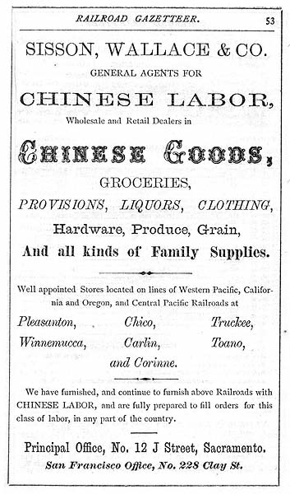

Advertisement in the Pacific Coast Railroad Gazetteer (1870)
http://www.historyiscentral.org/HSI/case1H/Doc2.jpg

J.O. Wilder, for many years a Central Pacific-Southern Pacific employee, in an interview with the late Erle Heath, one-time Southern Pacific historian, said:
The Chinese were as steady, hard-working a set of men as could be found. With the exception of a few whites at the west end of Tunnel No. 6, the laboring force was entirely composed of Chinamen with white foremen. A single foreman with a gang of 30 to 40 men generally constituted the force at work at each end of a tunnel; of these, 12 to 15 worked on the heading, and the rest on the bottom removing material. When a gang was small or the men needed elsewhere, the bottoms were worked with fewer men or stopped so as to keep the headings going.
The Chinese were paid $30 to $35 in gold a month, finding [maintaining] themselves, while the whites were paid about the same with their board thrown in.
[15] Erle Heath, editor of the Southern Pacific Bulletin, conducted question and answer interviews with various persons who had worked on the construction of the Central Pacific. Copies of these interviews are on file in the archives of the Southern Pacific Company in San Francisco.

The difference in the eating and drinking habits of the Chinese and white workers building the Central Pacific was as great as their other living habits. The Chinese menu included dried oysters, abalone, cuttlefish, bamboo sprouts, mushrooms, five kinds of vegetables, pork, poultry, vermicelli, rice, salted cabbage, dried seaweed, sweet rice crackers, sugar, four kinds of dried fruit, Chinese bacon, peanut oil, and tea. Seemingly, this was the forerunner of the modem American well-balanced diet. The fare of the Caucasian laborer consisted of beef, beans, bread, butter, and potatoes.
On the grade the Caucasians relieved their thirst with water —— not always the best and at times, despite all precautions, a source of illness. The Chinese drank luke-warm tea. It stood beside the grade in thirty and forty-gallon whiskey barrels, always on tap. Several times daily a Chinese mess attendant brought fresh tea, pouring it into the big barrel. These beverage reinforcements were carried to the work site in powder kegs suspended from each end of a bamboo pole which was balanced on a Celestial shoulder.[9]
"Food Habits of the Chinese," C.H.S.Q., XXXVII, 78, 80, 83, 130.

George Kraus. “Chinese Laborers and the Construction of the Southern Pacific,” The Last Spike is Driven. National Centennial Commission Official Publication. Central Pacific Railroad Photographic History Museum. Utah Historical Quarterly (Winter 1969), Vol 37, No. 1, pp. 41-57 http://utah.ptfs.com/awweb/awarchive?type=file&item=34650

”Long lines of horses, mules and wagons are standing in the open desert near the camp train. The stock is getting its breakfast of hay and barley. Trains are shunting in from the west with supplies and materials for the day's work. Foremen are galloping here and there on horseback giving or receiving orders. Swarms of laborers, Chinese, Europeans and Americans, are hurrying to their work.... By the side of the grade smokes the camp fires of the blue clad laborers who could be seen in groups waiting for the signal to start work. These are the Chinese, and the job of this particular contingent is to clear a level roadbed for the track. They are the vanguard of the construction forces. Miles back is the camp of the rear guard —— the Chinese who follow the track gang, ballasting and finishing the roadbed. . . .
The Chinese board themselves. One of their number is selected in each gang to receive all wages and buy all provisions. They usually pay an American clerk —— $1 a month apiece is usual —— to see that each gets all he earned and is charged no more than his share of the living expenses. They are paid from $30 to $35 a month, out of which they board themselves. They are credited with having saved about $20 a month. Their workday is from sunrise to sunset, six days in the week. They spend Sunday washing and mending, gambling and smoking, and frequently, old timers will testify, in shrill-toned quarreling.
. . .
Meanwhile on board the camp train cooks are preparing dinner, clerks are busy with accounts and records, and the telegraph wire is tapping back the needs for tomorrow in the way of material and supplies.
Twice a day the camp train moves to the end of the track —at noon to give all hands the hot dinner that six—hours of labor has earned and at night to give supper and sleeping accommodations.
Immediately on reaching the end of the track at night a telegraph wire is cut in from the last pole to the telegraph car and Sacramento is notified of the number of miles of track laid.”

As reported by the Alta California on November 9, 1868

George Kraus. “Chinese Laborers and the Construction of the Southern Pacific,” The Last Spike is Driven. National Centennial Commission Official Publication. Central Pacific Railroad Photographic History Museum. Utah Historical Quarterly (Winter 1969), Vol 37, No. 1, pp. 41-57
http://utah.ptfs.com/awweb/awarchive?type=file&item=34650

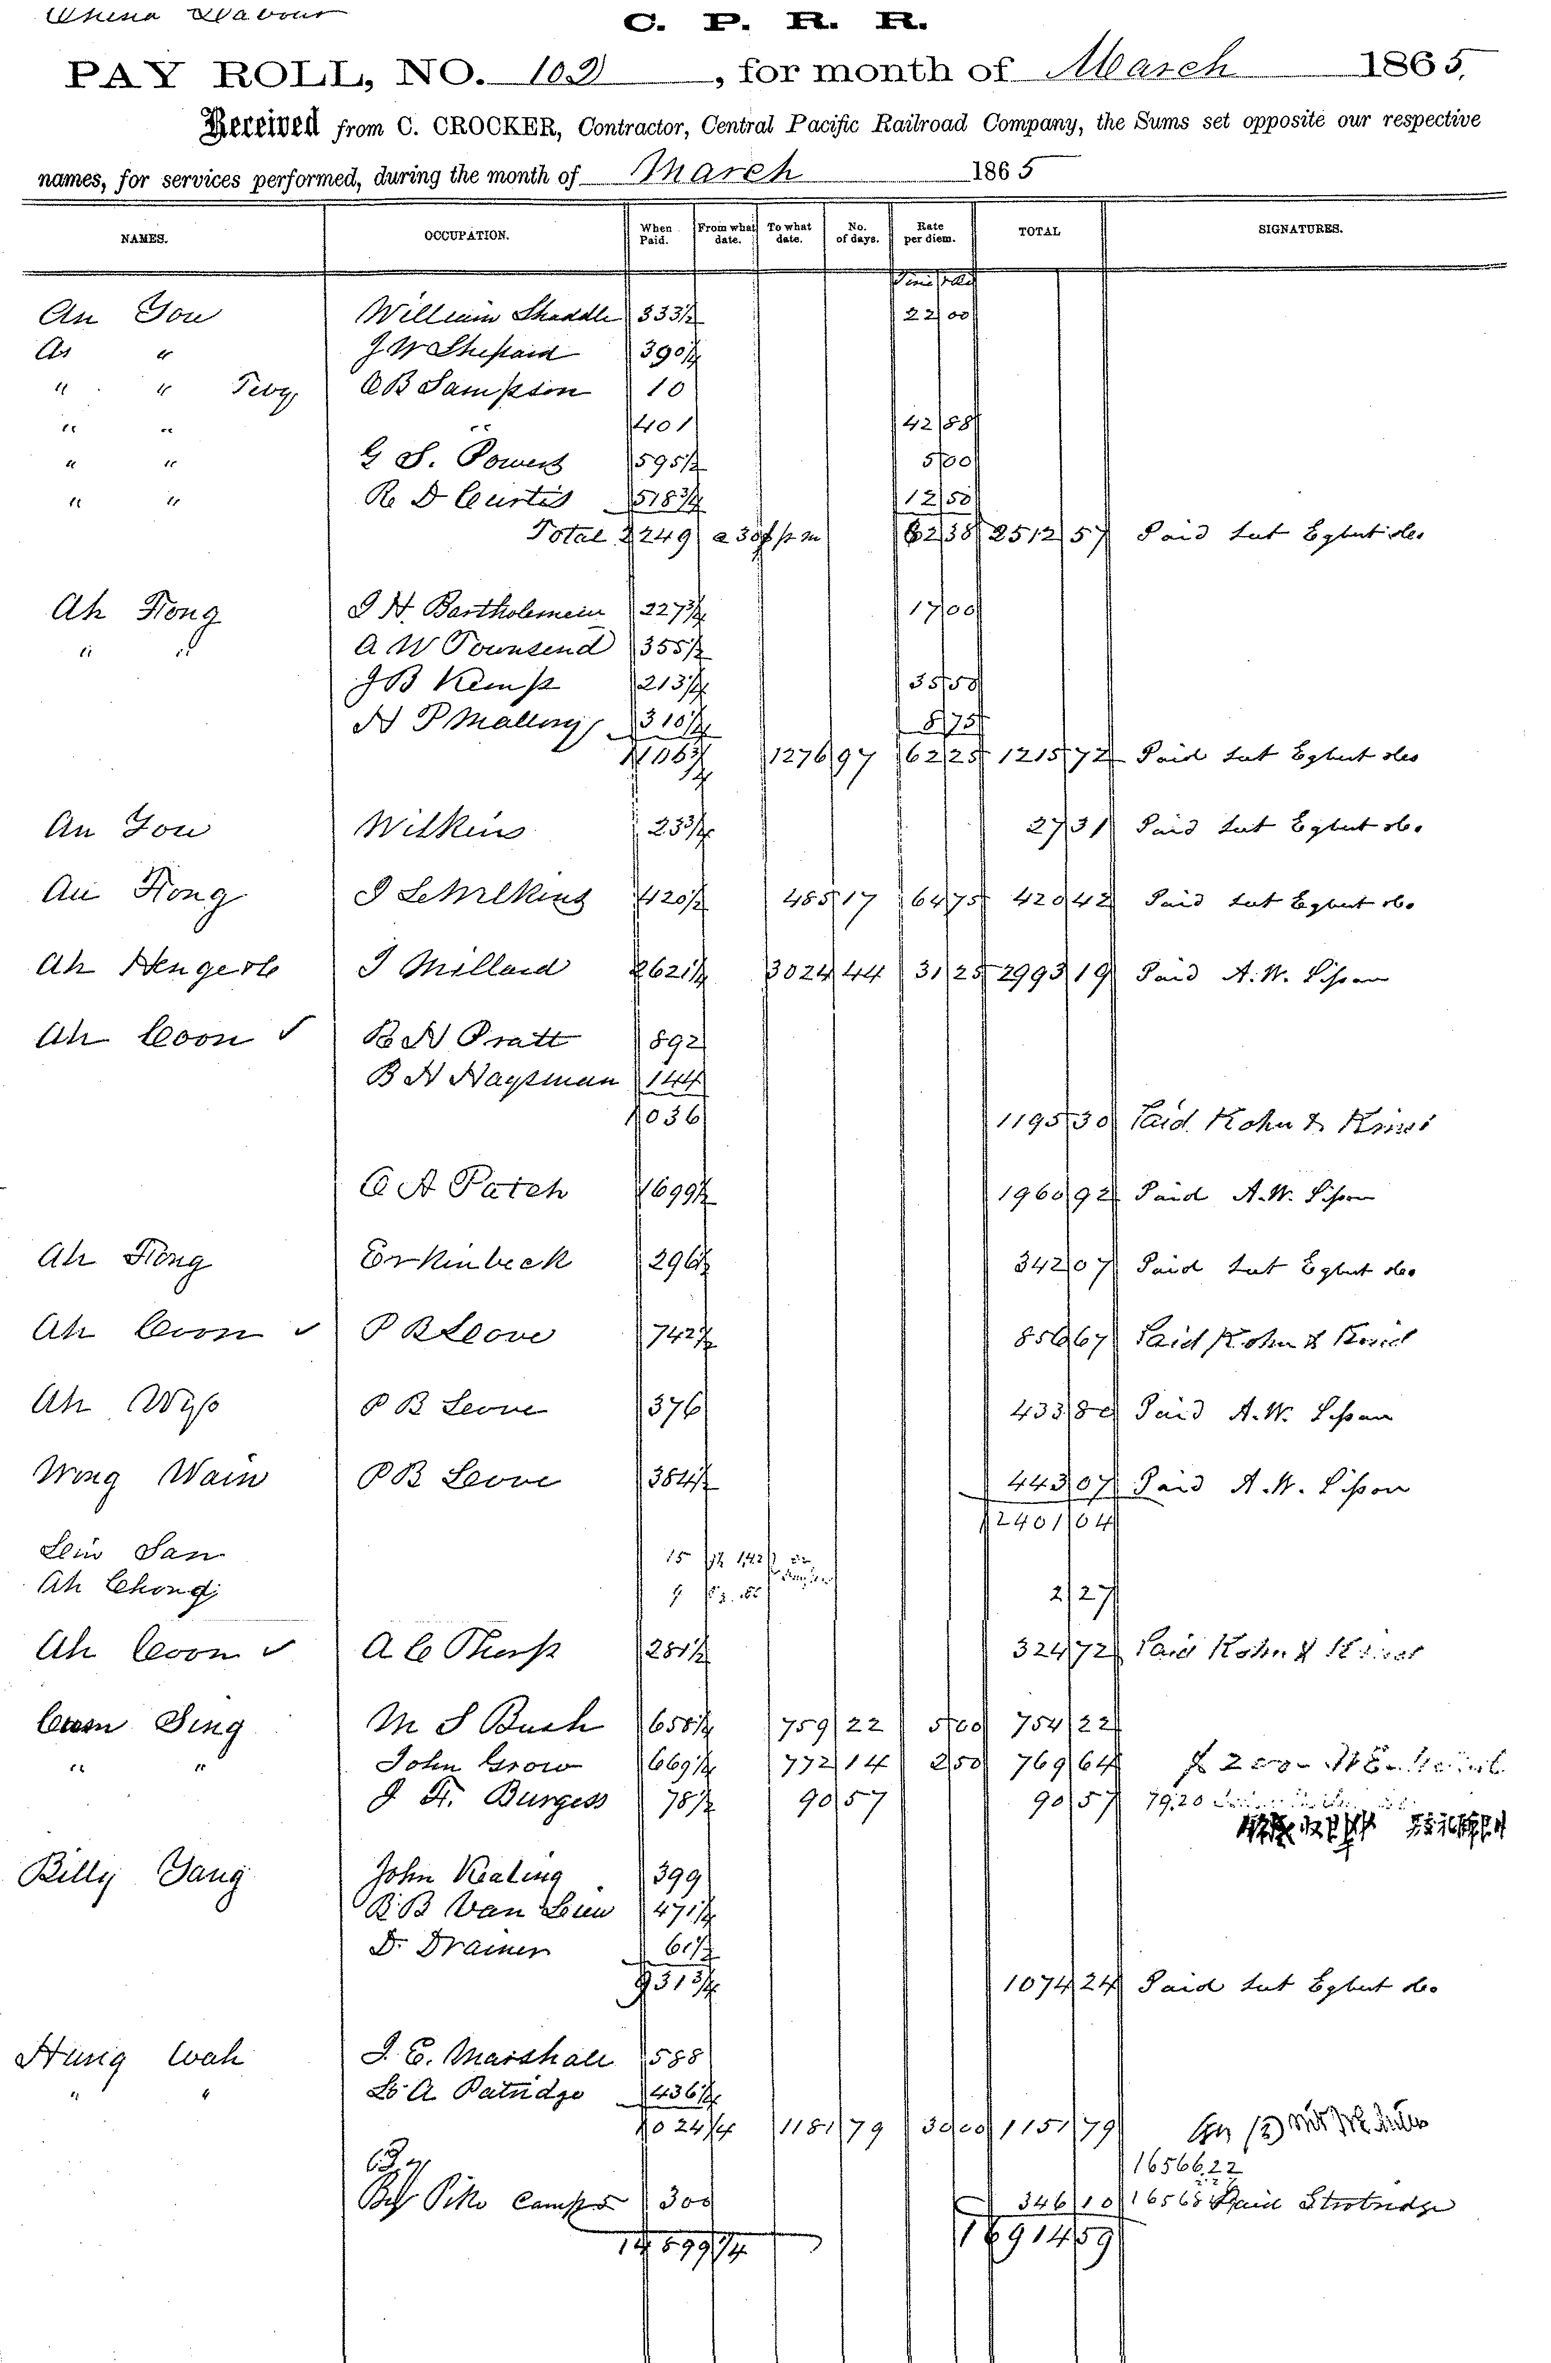
“Payroll Central Pacific Railroad”
Payroll No. 102 dated March 1865 for Chinese workers employed during the construction of the transcontinental railroad…The payrolls list the construction division for which the individuals worked, rates of pay and total pay received.
http://www.sacramentohistory.org/search.php?imageid=609

__________________

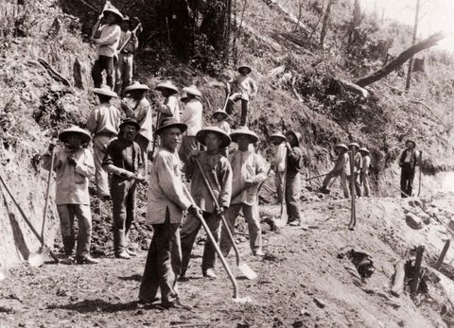
Chinese laborers on the Transcontinental Railroad.
From, “My People’s History,” By, Lisa Leong. (April 15, 2008) Posted in Voices From the Community.
http://www.asianweek.com/2008/04/15/my-peoples-history-asian-american/

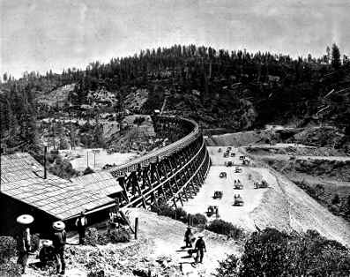
Secrettown Trestle
Chinese railroad workers transported dirt by the cartload to fill in this Secrettown Trestle in the Sierra Nevada Mountains. Courtesy of Union Pacific Historical Collection.
“Railroad Construction Employed Thousands,” Chinese Laborers in the West. http://apa.si.edu/ongoldmountain/gallery2/gallery2.html

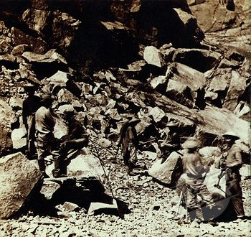
Stock Photo - Chinese workers wearing traditional clothing while excavating the track bed of the Central Pacific Railroad, in the Sierra Nevada Mountains of California. Ca. 1867.
Credit: Everett Collection / SuperStock 4048-6357-N-X999 http://www.superstock.com/stock-photos-images/4048-6357

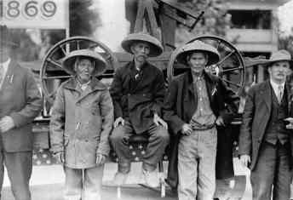
Surviving Union Pacific Chinament, Wong Food, Lee Chao, Ging Cui., Central Pacific Railroad Workers. Unidentified Artist, P1967.727 gelatin silver print. 1919
Central Pacific Railroad Workers. The Union Pacific Railroad hired 12,000-14,000 Chinese to level roadbeds, bore tunnels, blast mountainsides, and eventually complete the first transcontinental railroad in 1869.
Courtesy of Amon Carter Museum, Fort Worth, TX. Smithsonian Asian Pacific American Center. http://apa.si.edu/ongoldmountain/gallery2/gallery2.html

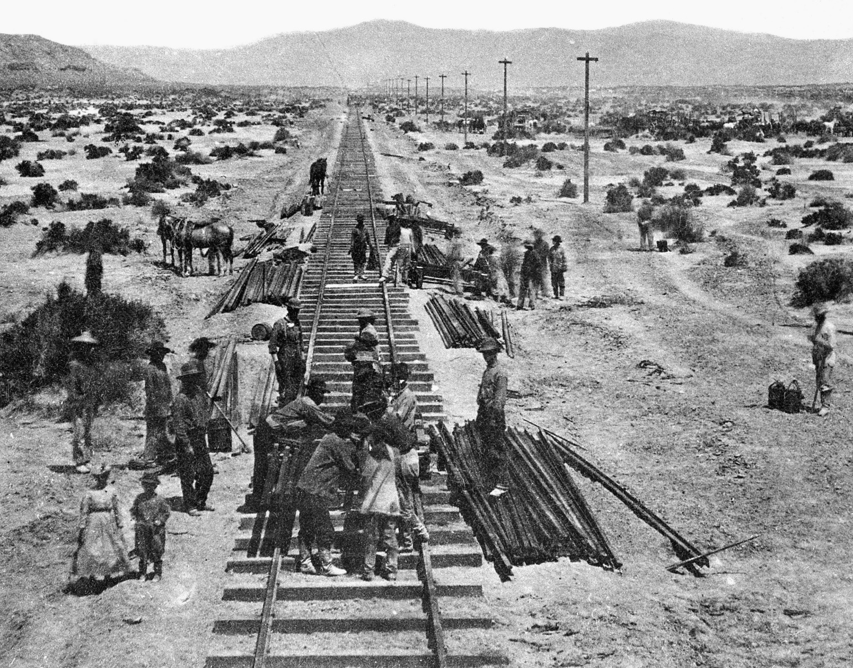

Track work takes place in Nevada as Central Pacific forces build the western link of the first transcontinental railroad, now a part of the Southern Pacific system, on May 10, 1868. Rail layers shown in the foreground were followed by gangs of Chinese laborers who spaced and spiked the rail to the ties. (AP Photo/Southern Pacific News Bureau)

Asian Americans in the United States: An Overview of a Difficult History, Asian Americans Journalists Association, A Timeline of the Chin Case, By AAJA National (May 22, 2013)
http://www.aaja.org/vc-timeline/
A note on these photo captions: AAJA’s license to use AP Images requires us to post the caption, byline and source for each photo. The captions that appear with each photo have been provided by AP and are not attributed to the Asian American Journalists Association.

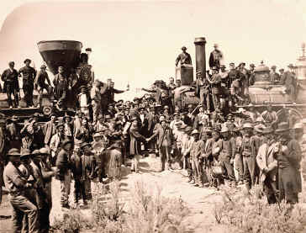

Joining the Tracks for the First Transcontinental Railroad, Promontory Point, Utah Newsline Photographer, Andrew J. Russel. On May 10, 1869, the final golden spike was driven at Promontory Point. Dignitaries did not invite Chinese workers to the official ceremony, despite their significant contribution and death toll for the national project.
Courtesy of Union Pacific Historical Collection. Smithsonian Asian Pacific American Center. http://apa.si.edu/ongoldmountain/gallery2/gallery2.html

A Timeline of Events (1850 – 1882)

1848 The Gold Rush begins with the discovery of gold at Sutter’s Mill, drawing many fortune seekers including the Chinese to California.
The discovery of gold spurred a mass migration of people into the State of California. In 1850, of the 57,000 people who migrated to California, only 500 were Chinese. Four years later, approximately 20,000 Chinese migrated to the United States. (CAM)
September 9, 1950
California becomes the 30th state admitted into the Union.
1852 20,000 Chinese enter the United States, mostly to California; only 17 are women. (CAM)
1860 Theodore Judah solves the great riddle of the Pacific Railroad when he reaches Donner Pass and recognizes it as the ideal location for constructing a line through the Sierra Nevada. (PBS)
1861-1865
American Civil War; 51 Chinese soldiers fought in the Civil War. (CAM)
1862 The 13th Amendment abolishes slavery.
1862 Pacific Railroad Act is signed into law by President Lincoln.**
This act provided for federal funding (money) to build the Central Pacific and Union Pacific railroads which were to eventually meet and join the eastern and western United States. With over 2,000 miles of tracks and built mostly by hand, the transcontinental railroad established a direct link from Nebraska to California.
1865 Charles Crocker convinces Central Pacific foreman James Harvey Strobridge to try Chinese workers as a means of expanding their labor force, which at this time numbers just a few hundred Irishmen. (PBS)

A Timeline of Events (#4 - Chinese Laborers on the Railroad) – continued (2)

1865-1869
The Transcontinental Railroad recruits thousands of Chinese laborers. (CAM)
Faced with white workers demanding higher wages and threatening strikes, Central Pacific Railroad Company of California reluctantly hired fifty Chinese laborers, who were considered too frail for the job. As the Chinese proved to be reliable workers, the company began to recruit more Chinese workers. While white workers were paid $35 a month with free board (a place to live), the Chinese were paid $26 to $35 without free board. When completed, 15,000 to 17,000 Chinese had worked on the railroad.
Summer 1865
Central Pacific crews begin the slow job of hand-drilling 12 tunnels through the Sierra Nevada, averaging a few inches through the rock a day. By year’s end, approximately 6,000 Chinese men will work in and around the tunnels. They will constitute up to 80% of the workforce throughout the project. (PBS)
1867 British chemist James Howden begins manufacturing nitroglycerin (a highly dangerous explosive) on-site in the mountains for the Central Pacific, eliminating the dangers of transporting the explosive. (PBS)
1867 Work in the Sierras grinds to a halt as Chinese workers strike (refuse to work) for better wages and shorter hours.
The railroad company cuts off food, supplies, and communication to the Chinese camps. One week later, the men will go back to work at the same wage. (PBS)
November 30, 1867
As the Chinese lay track, Central Pacific directors lead a ceremonial train excursion to the eastern side of the Sierra Nevada. (PBS)

A Timeline of Events (#4 - Chinese Laborers on the Railroad) – continued (3)
1868 The Burlingame Treaty allows unrestricted Chinese immigration to supply cheap labor to build railroads. (CAM)
1868 Mormon leader Brigham Young provides Mormon laborers to help with the work through the Utah desert. (PBS)
April 28, 1869
Victory Day. Charles Crocker decides he has one last thing to show the Union Pacific and the world. In a remarkable feat of strength and organization, his Central Pacific crews lay an unheard-of 10 miles of rail between sunrise and sunset. (PBS)
May 10, 1869 **
The Central Pacific Railroad (being built eastward from California) and the Union Pacific railroad (working westward from the Missouri River) are joined together at Promontory Point, Utah. The transcontinental railroad is complete.
1876 The Southern Pacific Railroad connects San Francisco and Los Angeles, California. *
3,000 Chinese railroad workers finished laying the last 1,050 feet of track linking northern and southern California. After completion of the railroad, hundreds of Chinese railroad workers move to Los Angeles. (CAM)
1882 Ignoring the crucial role the Chinese immigrants played in constructing the railroads and other parts of California, Congress passes the Chinese Exclusion Act to suspend immigration of Chinese laborers. (CAM; PBS)
Chinese laborers in the U.S. were not allowed to bring their wives or children to America. The Act also denied the Chinese already in America the right to naturalization and established the right to deport them.
The Chinese Exclusion Act marked the first time that the U.S. has ever barred entry of a group of people based on their ethnicity.

“A Timeline of Events,” Our American Journey, Educator’s Guide Chinese American Museum, Los Angeles, CA (2010), pp. 6-8, 14-15. (CAM)
Mark Zwonitzer, Producer. “Transcontinental Railroad,” American Experience – 25 Years. A HiddenHill Productions Film. (2003); Online: Public Broadcasting Station, http://www.pbs.org/wgbh/americanexperience/features/timeline (PBS)
*Asterisks denote content included in articles from Westways Magazine, Automobile Club of Southern California

